​DANTE ALIGHIERI (1265-1321)
The Divine Comedy (1307?-20)
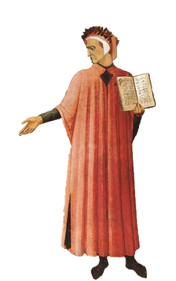
Perhaps the most lyrical and precise sustained poem ever written, Dante's Commedia traces its origins to the ancient epic tradition and its influence to the modern "novel of the self." Its heroic quest moves the hero from earth to hell, from purgatory to paradise, then back to earth again where the hero, returned, becomes the storyteller who leads the reader on the same quest for understanding both the cosmos and the self. Dante's break with the epic tradition was to make the hero himself, Dante Alighieri: "In the middle of the journey of our life, I found myself. . . '' Because of this brilliant, even arrogant, innovation, Dante's Commedia transcends the medieval character of its orthodox allegorical and religious dimensions to foreshadow the Renaissance.
Dante chose to write his masterpiece not in the traditional Latin of his earlier works, but in the Tuscan vernacular because, as he explains in his letter to Can Grande della Scala, the inferno treats of coarse and vulgar things; and because, despite the roughness of this first cantica (the Commedia is divided into three cantiche: Inferno, Purgatorio, and Paradiso), it is ultimately, by Greco-Roman definition, a "comedy" since its ending is happy, revealing that free will, guided by grace, can lead the questing pilgrim to the ultimate source of his quest: identification with the creator of the cosmos.
​Yet the pilgrim-hero of the story would never have succeeded in his pilgrimage from time to eternity were it not for the guidance of his pagan master, the epic poet Virgil (whom Dante meets in this first canto). Dante has embodied Christian grace as the single sufficient source of redemption with a pagan master! At journey's end (in Paradiso 33), the pilgrim Dante stands face to face with God and discovers reflected in the divine countenance, as though in a mirror, our own image.' As arrogantly iconoclastic as it may have seemed to Dante's contemporaries to identify the face of God with the visage of humanity, the identification has both past and future validity. On the one hand, it harks back to the words of the Bible's Genesis: in His own image and likeness He created "them"; on the other, the identification is a harbinger of Renaissance expressions like Pico della Mirandola's oration, On the Dignity of Man" and Michelangelo's ceiling of the Sistine Chapel.
