Enlightenment Philosopher Song Assignment
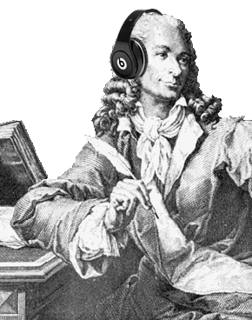
Objective: To apply your understanding of Enlightenment ideas and interpret them through modern day songs.
Procedure: You are to select any modern song that you feel best represents the ideas of one of the Enlightenment philosophers. After selecting a song you are to print out the lyrics of the song and change a majority of them to better reflect the ideas of your philosopher. (Remember Songs should be School Appropriate)

Final Product: Your final project must meet the following requirements (20 pts)
- Original Song Title/New Song Title
- Artist or Writer of the song
- Name of Philosopher
- Origin Lyrics
- Your changed lyrics to the song

Bonus Opportunity: Any students willing to perform their song in front of the class will receive up to 5 bonus points

