Mystery of the Indus Valley Civilization

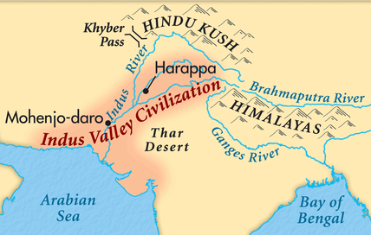
Researchers Paint New Portrait of an Ancient People
By John Noble Wilford
Renewed excavations and a re-examination of artifacts have awakened scholarly interest in everything about the Indus civilization: the sources of its economic strength and cultural cohesion, the puzzle of its undeciphered writing, the reasons for its rise in 2600 B.C. and decline around 1900 B.C. Many early assumptions and theories have been abandoned or revised. More than 1,500 sites of Indus settlements have been identified. But mysteries persist.
The new research has inspired an exhibition of Indus pottery and figurines, bangles and beads, which opens tomorrow at the Asia Society in New York City.
The Indus cities represented the beginning of urbanism in the Indian subcontinent. The people lived in large cities with thick brick walls and gateways to protect them and control trade. The cities were served by numerous water wells, bathing quarters and an extensive system of waste-water drains. The elites seemed to shun ostentation, apparently doing without elaborate palaces or temples. The view of this as a largely unmilitary culture is fostered by the absence of any iconography of battle or of spears and other obvious instruments of warfare.
According to the original view, the Indus people were austere, peaceful, urban, merchant burghers, a kind of ancient version of the Hanseatic mercantile culture of northern Europe. When the British archeologist Mortimer Wheeler excavated more intensively in the valley after World War II, a new interpretation emerged: this was a state ruled by priest-kings, its wealth based on agriculture and trade, a dull and regimented society that bore a strong likeness with Mesopotamia. This view also has been largely rejected.
''You catch us at a moment of change and re-interpretation,'' Dr. Possehl said in an interview at the University Museum of Archeology and Anthropology in Philadelphia.
Before him was a table laid with Indus artifacts: assorted pottery with fish-scale designs, woodland scenes and peacocks; a seal bearing the impression of a unicorn; a clay rattle and a toy cart also made of clay, and several small figurines, including one of a potbellied man.
Dr. Possehl stood there pondering a question: Why is it taking so long to come up with new interpretations explaining the Indus success?
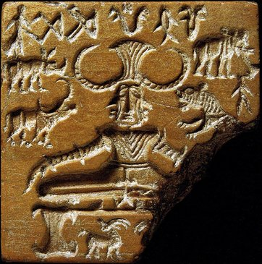
'We have a stubborn problem; call it a double-whammy problem,'' Dr. Possehl said, finally. ''So much archeological reconstruction of a civilization depends on an interplay of physical remains and written records. Forget about Indus writing. We can't decipher it and, besides, we have found no inscriptions of more than 26 characters, so we are left with no long narratives. Also, the physical remains, the archeological expressions of the Indus people, don't look like anything we are familiar with -- no palaces or monuments or temples.''
Dr. Possehl, who has excavated Indus cities since the 1960's and written several books on the culture, also lamented the apparently simple Indus burial practices, which deprive archeologists of what is usually a most revealing lode of cultural information.
Unlike the elites of Egypt and Mesopotamia, the Indus people sent their dead to the afterworld unaccompanied by jewels, furniture and weapons. ''That's an attitude,'' he said. ''Stuff is kept in circulation with living people.''
Excavations at Harappa, Dr. Kenoyer said, indicated that some people were buried in wooden coffins with pottery vessels that may have been filled with food. But having found so few cemeteries, archeologists suspect that burial was not the rule; perhaps most bodies were cremated or thrown into rivers.
Simple burials seem to fit the one persistent image of Indus society, which is that of a practical people without centralized rulers or kings but with wide-ranging economic interests. Somehow they introduced millet cultivation from Africa. Mesopotamian cuneiform tablets record the presence of Indus merchants and ships there during the reign of Sargon the Great, founder of the Akkadian kingdom, around 2300 B.C. The texts mention such trade goods as hardwoods, tin or lead, copper, gold, silver shell, pearls and ivory.
In other excavations, archeologists have found distinctive Indus cubical weights, made of chert or agate and used for measuring goods before a transaction, at many sites of Arabian Sea ports. These weights have also turned up at all Indus settlements. However, the large number of them recovered, along with small copper scale pans, near Harappa's main gate has led Dr. Kenoyer to suspect that the weights were not used primarily for trading but for assessing taxes on goods being brought into or taken out of the cities.
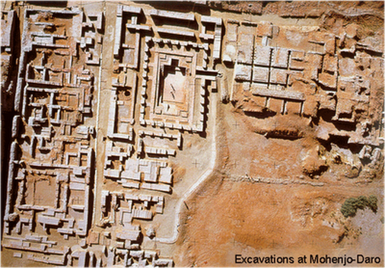
Even if the cities reveal no monumental traces of strong rulers, all around is indirect evidence of some kind of organizing influence. Who oversaw foreign commerce by sea and regulated the system of weights? How to explain the apparently common religion, uniform pottery and coherent Indus style of artifacts over a period of 700 years, spanning nearly 30 generations?
''We have the peculiar expression of an ancient sociocultural complexity without the ostentations of ideology or evidence of a focused leadership, like a king or queen,'' Dr. Possehl said. ''There's no real model in history or ethnography that suggests that somewhere else there was a civilization like this one.''
The Indus cities themselves attest to the presence, if not the identity, of some powerful guiding hand in the culture.
Dr. Michael Jansen, an archeologist at the University of Aachen in Germany, calls Mohenjo-daro ''a founder city.'' That is, like Alexandria, the Egyptian city ordered built by Alexander the Great, Mohenjo-daro bears all the signs of a city that was willed into existence by some powerful person or group of people. The streets were straight, laid out on a north-south and east-west grid. Houses of brick on top of stone foundations seem to have been built to standard designs. Nearly all of them were connected to a city-wide drainage system, and each block had one or more water wells.
The most imposing part of Mohenjo-daro was the Mound of the Great Bath, originally thought of as a citadel. Built on a high mound of dirt and brick rising from the flood plain, this upper city covered an area about 600 feet by 1,200 feet. Its largest building is sometimes described as a warehouse for grain and other agriculture products, though some archeologists think it was more likely a residence or meeting hall for powerful merchant families. The bathhouse itself included a sunken courtyard lined with closely fitted bricks for a watertight pool, which was surrounded by colonnaded halls.
''This is the only piece of architecture we have that is reasonably convincing as something to do with ritual,'' Dr. Possehl said. ''It's not your Y.M.C.A., but a place where some select part of the population came to do their ritual ablutions.''
They began carving seals on ivory and terra cotta and decorating pottery with graffiti, the beginning of the culture's writing. Perhaps of special importance was the expansion of long-distance trading networks.
The civilization, however it was tied together, began unraveling in the early second millennium B.C. The end is usually dated at 1900 B.C.
As for the causes, archeologists cite new research that rules out invasion by Indo-Aryan hordes from the north. That was the earliest hypothesis advanced by Mortimer Wheeler. But the Rig Veda, the liturgical writings of the nomadic Aryans, was not composed until about 1000 B.C., making it unlikely that these people were in the Indus region at the time of the collapse. Besides, the historical validity of the Rig Veda has not been established.
In his book, Dr. Kenoyer wrote: ''We now believe that there was no outright invasion. The decline of the Indus cities was the result of complex factors. Overextended economic and political networks, the drying up of major rivers as well as the rise of new religious communities all contributed in some way to the creation of a new social order.''
Calling what happened a collapse may be overstating the situation, archeologists said. True, Mohenjo-daro was suddenly abandoned, probably because the Indus River changed course, and when a parallel stream, the Saraswati or Ghaggar-Hakra river, dried up, the effect must have been devastating over a wide area. But Harappa continued to exist after 1900 B.C., though with a greatly diminished population. Other cities suffered sharp declines.
​
In the end, the civilization did not so much collapse as disintegrate or de-urbanize, for reasons that may not be fully known until the Indus script can be deciphered. Then the civilization faded into the background and became truly ''lost'' until the buried stones and bricks of it cities were uncovered.
​​
Questions:
Answer the following questions after completing the reading
- Why were the Indus thought to not be a military culture?
- According to Dr. Possehl way is it taking so long to understand the Indus?
- Why can’t the Indus language be deciphered?
- How did the Indus treat the dead? Why does that hamper our understanding?
- What evidence suggests that the Indus maintain a wide trading network?
- Why does Dr. Jansen believe that Mohenjo-daro was “willed into existence by some powerful person or group of people”?
- What was the Mound of the Great Bath? What function did it serve? What caused the downfall of Indus valley civilization?
- Why was invasion from the Indo-Aryan hordes ruled out?

