Niqab

Introduction
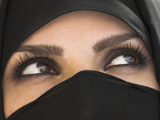A woman in niqab ©
Niqab is different from hijab. Hijab refers to covering everything except the hands and face. Niqab is the term used to refer to the piece of cloth, which covers the face, and women who wear it usually cover their hands also. It is worn by many Muslim women across Saudi Arabia and the Indian subcontinent and is worn by many women in the West.
Historically, the veiling of the face was practiced by many cultures before Islam and scholars say the adoption of its practice by Muslims was part of fitting into the society.
Although the majority of scholars agree that hijab is obligatory, only a minority of them say that the niqab is.
The scholars who do say it is obligatory are further divided by exactly what they believe needs to be covered. Some say that the eyes may be left unconcealed, while others say that everything must be concealed.
However, those scholars who rule that niqab is not an obligation do not necessarily oppose those who choose to wear it.
The most authentic ruling according to the majority of scholars is that it is not necessary and, unlike hijab, there is no sin if it is not worn. Some of these scholars state that wearing the niqab as an act of extra piety, provided they do not believe it is an obligation, will be rewarded.

Muslim headscarves
The word hijab comes from the Arabic for veil and is used to describe the headscarves worn by Muslim women. These scarves come in myriad styles and colours. The type most commonly worn in the West is a square scarf that covers the head and neck but leaves the face clear.

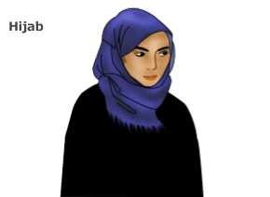

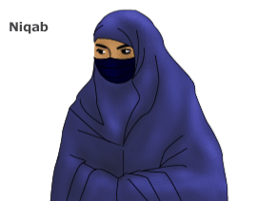
The niqab is a veil for the face that leaves the area around the eyes clear. However, it may be worn with a separate eye veil. It is worn with an accompanying headscarf.

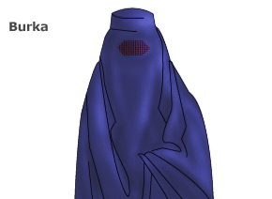
The burka is the most concealing of all Islamic veils. It covers the entire face and body, leaving just a mesh screen to see through.

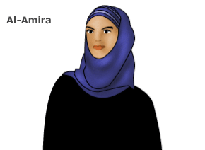
The al-amira is a two-piece veil. It consists of a close fitting cap, usually made from cotton or polyester, and an accompanying tube-like scarf.

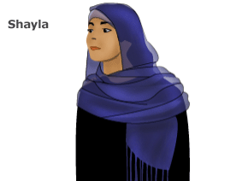
The shayla is a long, rectangular scarf popular in the Gulf region. It is wrapped around the head and tucked or pinned in place at the shoulders.

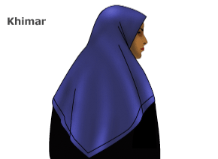
The khimar is a long, cape-like veil that hangs down to just above the waist. It covers the hair, neck and shoulders completely, but leaves the face clear.

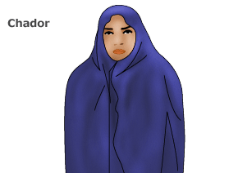
The chador, worn by many Iranian women when outside the house, is a full-body cloak. It is often accompanied by a smaller headscarf underneath.

The case for niqab

Evidence for the obligation of niqab
There are only a few references to veiling in the hadith and most of these actually refer to the khimar, which is restricted linguistically to head covering. The covering of the face is only mentioned in three hadith and never by the command of the Prophet Muhammad. In fact, in one hadith, the companions of the Prophet Muhammad are even surprised at one woman's wearing of the niqab during her time of bereavement.
The main evidence from scholars who believe that niqab is obligatory comes from these verses of the Qur'an.
O Prophet! Tell thy wives and daughters, and the believing women, that they should cast their outer garments over their persons (when abroad): that is most convenient, that they should be known (as such) and not molested. And Allah is Oft- Forgiving, Most Merciful.
Qur'an 33:59
Scholars, such as Imam Abul A'la Mawdudi from the Indian subcontinent, suggest that these verses refer to covering the entire body, including the face and hands. The order 'cast their outer garments' in Arabic is similar to phrase 'draw together'. Scholars say that as a result of this verse, the women at the time of the Prophet drew together their garments over their entire body, including the face.
One hadith that is used as evidence for this is:
Narrated 'Aisha (wife of Prophet Muhammad): The Messenger of God, may the peace and blessings of God be upon him, used to offer the Fajr prayer and some believing women covered with their veiling sheets used to attend the Fajr prayer with him and then they would return to their homes unrecognized.
Bukhari
This hadith has been dated some time after verse 33:59 was revealed. Proponents of the niqab say that this hadith shows that the women during the time of the Prophet were not recognizable and hence they must have worn niqab.
However, other scholars have argued that their faces were unrecognizable because it was dark, not because they were covered up. It is interesting to note that Aisha says 'some' women, and not all. Furthermore, she refers to the early-morning prayer and not to any other. It would certainly make it more difficult to see who individuals were if they were dressed in cloaks before sunrise.
In addition, they have argued that the order 'cast their outer garments over their persons' has been misunderstood. They say that the word 'face' has not been indicated in the Arabic, and it would therefore be wrong to extend the meaning.
Other proponents of the niqab use this Qur'anic verse for evidence for the niqab.
...And when ye ask (the Prophet's wives) for anything ye want, ask them from before a screen: that makes for greater purity for your hearts and for theirs.
Qur'an 33:53
The wives of the Prophet were indeed required to wear the niqab by this Qur'anic verse. This is because the special status they had meant they had to be kept clear from all gossip and slander. Scholars say that if the wives of the Prophet, as the best of feminine examples, were required to wear niqab, then the ruling falls on all women.
However, earlier on in the same chapter, the Qur'an also very clearly states that the Prophet's wives were not similar to other women.
O Wives of the Prophet! You are not like any of the other women.
33:32
Most scholars are in agreement that the verse about the screen, or concealing of the face, is only obligatory on the wives of the Prophet. They say the verses are a clear indication that the wives of the Prophet are much more restricted in their movement due to their political position, and that their code of conduct does not constitute a code of conduct for women in general.
The case against niqab

Evidence against the obligation of niqab
Most scholars, including the four main schools of Islamic jurisprudence, hold the view that niqab is not an obligation.
They cite a number of references for this opinion.
Say to the believing men that they should lower their gaze and guard their modesty: that will make for greater purity for them: And Allah is well acquainted with all that they do.
And say to the believing women that they should lower their gaze and guard their modesty; that they should not display their beauty and ornaments except what (must ordinarily) appear thereof...
24:30-31
According to the majority of contemporary scholars, 'what is apparent of it' refers to the hands and face.
Another scholar, Shaykh Kutty, a senior lecturer and an Islamic scholar at the Islamic Institute of Toronto, Ontario, Canada suggests that because God asks both men and women to lower their gaze, it suggests their faces are visible, otherwise there would be no sense in it.
Scholars holding this view also state that it is well accepted by all scholars that the Prophet categorically forbade people from covering their faces or hands during hajj, the pilgrimage to Mecca. If it was necessary that the hands and face be covered at all times, he would not have stated its impermissibility during one of the most sacred points of a person's life.
It is also generally held by the majority of scholars, including those that believe niqab is obligatory, that covering the face during the five daily prayers is also prohibited.
Another strong indication that niqab is not an obligation is presented in this hadith.
Abdullah bin Abbas reports that the Prophet was riding a camel with Al-Fadhl, Abdullah's brother, behind him. A beautiful woman came to ask the Prophet about the Hajj of her father. Al Fadhl began to stare at her; her beauty impressed him a lot. The Prophet (peace be upon him) having noticed this while Al Fadhl was busy looking, put his hand behind and turned his face away from her hither and thither as she went along with them. Al Abbas said to the Prophet, "you are twisting the neck of your nephew!" The Prophet replied, "I noticed that both the boy and the girl were young; and I feared that Satan may intervene".
Tirmidhi and Bukhari
Scholars argue that the Prophet controlled the boy Al Fadhl's gaze, but did not mention the fact that the woman was not covering her face. As a rule, anything that Prophet Muhammad stays silent about is tacit approval. This hadith would seem to indicate strongly that niqab is not obligatory.

Scholars in the west

Obligation vs recommendation
Some contemporary scholars have gone further in their rulings about the niqab in the West. Although they may agree with its practice in Muslim countries, they say that it is harmful in the West and should therefore be avoided.
Shaykh Darsh, a prominent UK scholar, did not believe that the niqab was necessary, or even recommended by the Prophet for women to wear. But if you were going to argue that niqab was a recommended act, he explained his opinion for wearing niqab in this country in the following way:
- Some people believe that niqab is recommended (sunnah)
- Everybody believes that inviting people to Islam (da'wah) is obligatory (fardh)
- The niqab is often a very significant barrier to da'wah in the West where the concept of face covering has never been known
- If a recommended act is a barrier to an obligatory act, one must not sacrifice the fardh for the sunnah
Shaykh Nuh Keller, a Jordanian Shafi'i scholar and translator of Reliance of the Traveler, has put forward a similar argument for women in the West. He says that women should not wear niqab in the West because it can lead to harassment and act as a barrier to inviting people to Islam.

A question of choice

Freedom of choice
Although the much stronger scholarly opinion holds that the niqab is not an obligation in Islam, it is appreciated that there is an opinion, which believes it is. Differences in opinion are respected and celebrated, which is why a follower of one of these opinions will rarely say the other is completely wrong, or haram.
Niqab has a place in Islam, since the Prophet's wives were required to wear them. In today's context, many women attempt to emulate the best of women to bring themselves closer to God.

